Math Reviewer
Ratio and Proportion
Ratio and Proportion:
- Ratio – Comparison between two or more quantities showing how many times one value contains another. It expresses relative size, not absolute amount. It tells relationship in quantity, not total count.
- Proportion – An equation that states two ratios are equal. It shows that two relationships match.
- Extremes – The first and last terms (a and c)
- Means – The middle terms (d and b)
- Property – The product of the means equals the product of the extremes (ad = bc)
$$\frac{a}{b}=\frac{c}{d} or \left(a\right)\left(d\right)=\left(b\right)\left(c\right) or "a is to b"$$

Similar Figures
Similar Figures:
- Similar Figures – In geometry, similar figures are shapes that have the same shape but may have different sizes. This means their corresponding angles are equal, and their corresponding sides are in proportion.
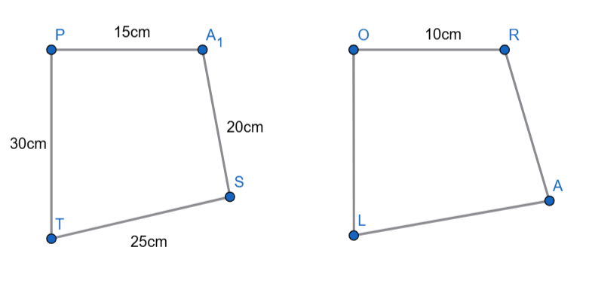
- Finding the Common Ratio or Scale Factor of □PAST and □ORAL:
$$\left(\frac{PA}{OR}=\frac{AS}{RA}=\frac{ST}{AL}=\frac{TP}{OL}\right)= \left(\frac{15}{10}=\frac{20}{RA}=\frac{25}{AL}=\frac{30}{OL}\right)$$
$$\frac{15}{10}=\frac{3}{2} (scale factor is\frac{3}{2})$$
- Finding the Missing Length of □PAST and □ORAL:
$$RA=\left(\frac{15}{10}=\frac{20}{RA}or\left(15\right)\left(RA\right)=(10)(20)\right)=\left(\frac{15RA}{15}=\frac{200}{15}\right)=\frac{40}{3}centimers$$
$$AL=\left(\frac{15}{10}=\frac{25}{AL}or\left(15\right)\left(AL\right)=(10)(25)\right)=\left(\frac{15LA}{15}=\frac{250}{15}\right)=\frac{50}{3}centimeters$$
$$OL=\left(\frac{15}{10}=\frac{30}{OL}or\left(15\right)\left(OL\right)=(10)(30)\right)=\left(\frac{15OL}{15}=\frac{300}{15}\right)=20centimeters$$

- Finding the Perimeter of □PAST and □ORAL:
$$□PAST=\left(PA+AS+ST+TP\right)=\left(15+20+25+30\right)=90centimeters$$
$$ORAL=\left(OR+RA+AL+LO\right)=\left(10+\frac{40}{3}+\frac{50}{3}+20\right)=\left(10+\frac{40}{3}+\frac{50}{3}+20\right)=60 centimeters$$

- Finding the Ratio of the Perimeter:
$$OP=\frac{P□PAST}{P□ORAL}=\frac{90}{60}=\frac{3}{2}$$

Theorem Formulas:
- Similar AA Theorem – $180°-\left(x°+y°\right)$
- Similar SSS/SAS/HL/LL Theorem - $\frac{a}{b}=\frac{c}{d} or \left(a\right)\left(d\right)=\left(b\right)\left(c\right)$

Theorems:
- Isosceles Triangle Theorem – If two sides of a triangle are equal, then the angles opposite those sides are also equal. This explains why base angles in an isosceles triangle are always congruent.
- Converse of Isosceles Triangle Theorem – If two angles of a triangle are equal, then the sides opposite those angles are equal. This helps identify an isosceles triangle by looking at its angles.
- Unequal Angles Theorem – In any triangle, the larger side is opposite the larger angle, and the smaller side is opposite the smaller angle. This shows the relationship between side length and angle size.
- Converse of Unequal Angles Theorem – The larger angle is opposite the longer side, and the smaller angle is opposite the shorter side. This is used to compare sides by examining angle measures.
- Exterior Angle Theorem – The exterior angle of a triangle is equal to the sum of the two remote interior angles. It is useful for finding missing angles without knowing all interior angles.
- Triangle Sum Theorem – The sum of the interior angles of a triangle is always 180°. No matter the shape or size, all triangle interior angles add up to 180°.
- Triangle Inequality Theorem – The sum of any two sides of a triangle must be greater than the third side. This determines whether three given lengths can form a triangle.
- Right Triangle Pythagorean Theorem – In a right triangle, a² + b² = c², where c is the hypotenuse. It is used to find missing side lengths in right triangles.
- Converse of Pythagorean Theorem – If a² + b² = c² for a triangle, then the triangle is a right triangle. It is used to verify whether a triangle has a right angle.

Trigonometry
Pythagorean Theorem:
- Pythagorean Theorem – Is a rule in geometry that applies only to a right triangle (a triangle with one 90° angle). In a right triangle, the square of the length of the hypotenuse is equal to the sum of the squares of the lengths of the other two sides.
$$a^{2}+b^{2}=c^{2}$$
$$a = length of the first leg$$
$$b = length of the second leg$$
$$c = length of the hypotenuse (the side opposite the right angle and always the longest side)$$

The Six Trigonometric Ratios:
- Trigonometric Ratios – Trigonometric ratios describe the relationship between angles and side lengths in a right triangle.
- Sine $(sin θ)$ – The ratio of the Opposite side to the Hypotenuse in a right triangle.
- Cosine $(cos θ)$ – The ratio of the Adjacent side to the Hypotenuse.
- Tangent $(tan θ)$ – The ratio of the Opposite side to the Adjacent side.
- Cosecant $(csc θ)$ – The reciprocal of sine, ratio of Hypotenuse to Opposite.
- Secant $(sec θ)$ - The reciprocal of cosine, ratio of Hypotenuse to Adjacent.
- Cotangent $(cot θ)$ - The reciprocal of tangent, ratio of Adjacent to Opposite.
SOH-CAH-TOA | CHO-SHA-CAO
$$sinθ=\frac{Opposite}{Hypotenuse}$$ | $$cscθ=\frac{Hypotenuse}{Opposite}$$
$$cosθ=\frac{Adjacent}{Hypotenuse}$$ | $$secθ=\frac{Hypotenuse}{Adjacent}$$
$$tanθ=\frac{Opposite}{Adjacent}$$ | $$cotθ=\frac{Adjacent}{Opposite}$$
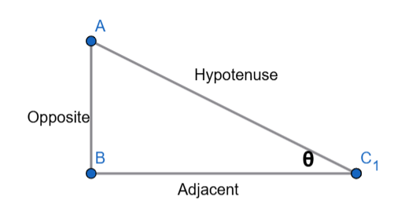 | 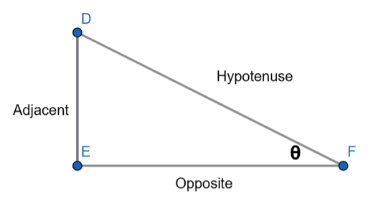
THIS IS NORMAL | (THETA SHOULD BE AT TOP)

Reciprocal Definition Rules
$$csc\left(θ\right)=\frac{1}{sin\left(θ\right)}$$ | $$sec\left(θ\right)=\frac{1}{cos\left(θ\right)}$$ | $$cot\left(θ\right)=\frac{1}{tan\left(θ\right)}$$

